CSA1606-DWDM
NAME: SWETHAMBIGAI.S
REG_NO : 192565064

Activity 1: Sales Analysis Dashboard
Problem Statement
A retail company wants to analyze its monthly sales.
Task
Build a KNIME workflow that:
• Imports a sales dataset.
• Cleans missing values.
• Calculates monthly sales.
• Identifies the top 10 products.
• Creates bar and line charts.
• Generates a summary report.
Expected Outcome:
An interactive sales analysis workflow.

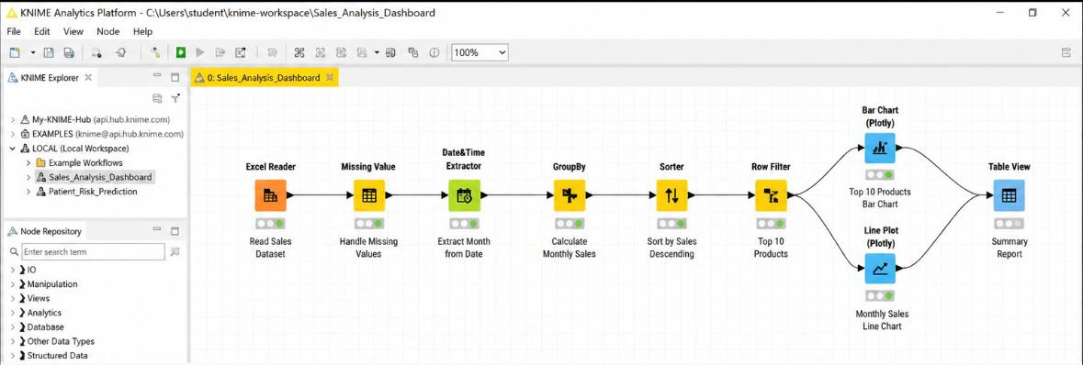

Activity 2: Hospital Patient Risk Prediction
Problem Statement
A hospital wants to predict whether a patient is at high or low health risk.
Task
Develop a workflow to:
• Import patient records.
• Preprocess data.
• Train a Decision Tree model.
• Predict patient risk.
• Evaluate accuracy using a confusion matrix

